MSIS 638

Case 1.2b

Jia Liang Ma

a)

Search the Travel Salesman Problem (TSP) and read about it.

b)

Imagine our company need to deliver some goods form **Boston, MA** to the following cities by an 18-wheeler truck and return to the Boston base.

**New York, NY**

**Buffalo, NY**

**Indianapolis, IN**

**Washington, DC**

**Charleston, WV**

**Charlotte, NC**

**Pittsburg, PA**

c)

This problem can be formulated as a Travel Salesman Problem. (Given a list of cities and the distances between each pair of cities, find the shortest possible route that visits each city exactly once and returns to the origin city.)

d)

Propose three ways (criteria) you can define length of a route.

1. Total distance traveled. (miles)

2. Arrival time.

3. Costs of driving.

e)

Propose at least three reasonable routes. (including a map)

1. From Boston to Buffalo, Pittsburg, Indianapolis, Charlotte, Charleston, Washington DC, New York and back to Boston. (Route A)

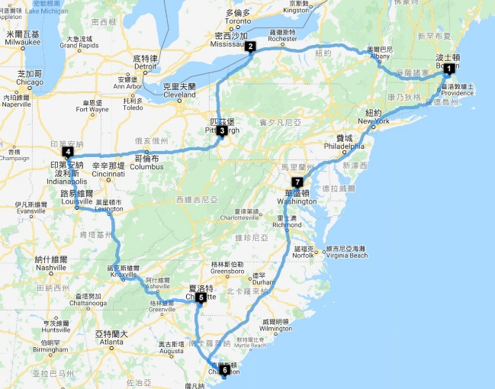

2. From Boston to New York, Washington DC, Pittsburgh, Charlotte, Charleston, Indianapolis, Buffalo and back to Boston. (Route B)

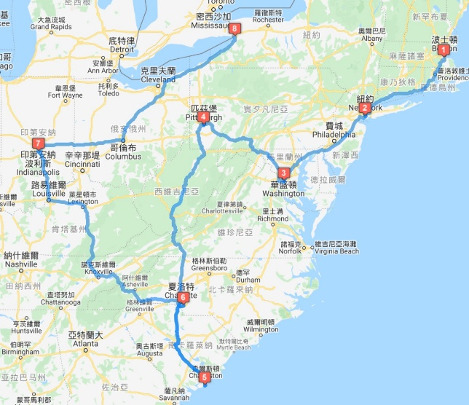

3. From Boston to New York, Washington DC, Charleston, Charlotte, Indianapolis, Pittsburgh, Buffalo and back to Boston. (Route C)

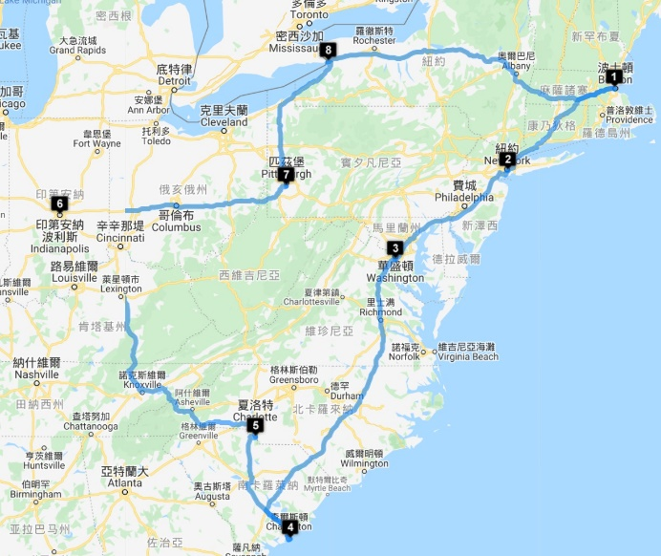

(<http://www.gebweb.net/optimap/>) Map routing and distances website

f)

Calculate the corresponding “length” for each route using each of the criteria and find the best route based on each criterion.

1. Length for each route:

a. Route A: 2571.9 miles

b. Route B: 2728.5 miles

c. Route C: 2395.6 miles

2. Time:

a. 1 day 21 hrs. 29 min.

b. 1 day 20 hrs.

c. 1 day 19 hrs. 13 min.

3. Costs of driving:

a. $257.9

b. $259

c. $256.7

(<https://www.travelmath.com/stopping-points/>) Costs calculation website.

We suppose the company want the fastest time because of VIP ordering, time and length will be important during weighting the criteria. (1~10)

Length: 7

Time: 8

Cost: 6

g)

Which route will you choose and why?

According to the weight criteria, the optimal solution is route C.

The reason for choosing route C is that it has the best time saving and the shortest range compared with other options.

h)

Explain three challenges we have faced in applying TSP in a real-world setting.

1. Hard to include all the possible criteria and situation to find an accurate solution.

2. Information using excel to integrate is quite hard in real-world setting and it is hard to collect all the data and turn into useful information.

3. Concerning like roadblocks and some real-time activities would become a problem.